**HTML5 Assignment**

1. What are the new tags added in HTML5?

Ans: - 1. <header>

2. <nav>

3.<section>

4.<audio>

5.<video>

6.<footer>

7.<main>

8.<table>

1. How to embed audio and video in a webpage?

Ans: - Audio Embed in HTML using of <audio> tag.

<!DOCTYPE html>

<html lang="en">

<head>

    <meta charset="UTF-8">

    <meta name="viewport" content="width=device-width, initial-scale=1.0">

    <title>Audio Embed</title>

</head>

<body>

    <!-- audio embed in webpage -->

    <h1>Audio File</h1>

    <audio controls src="file_example_MP3_700KB.mp3"></audio>

</body>

</html>

Audio Embed output in Webpage

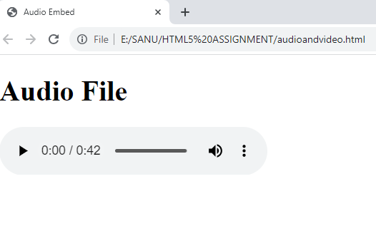

Video Embed in HTML using of <video> tag.

<!DOCTYPE html>

<html lang="en">

<head>

    <meta charset="UTF-8">

    <meta name="viewport" content="width=device-width, initial-scale=1.0">

    <title>Video Embed</title>

</head>

<body>

    <!-- Video Embed in webpage -->

    <h1>Video File</h1>

    <video controls src="sample video.mp4"></video>

</body>

</html>

Video Embed output in Webpage

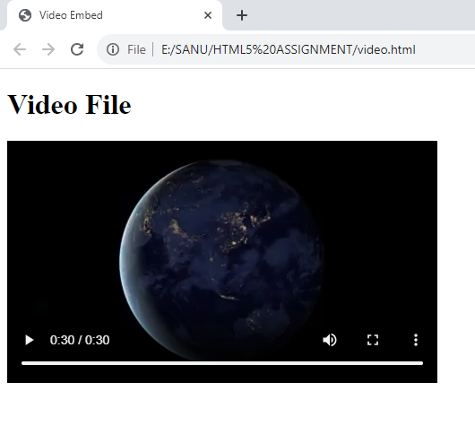

1. Semantic element in HTML5?

Ans: - In HTML there are some semantic element that can be used to define different parts of webpage.

* <header>
* <nav>
* <section>
* <aside>
* <article>
* <footer>

1. Canvas and SVG tags

Ans: -

|  |  |
| --- | --- |
| **SVG** | **HTML Canvas** |
| SVG has better scalability. So it can be printed with high quality at any resolution | Canvas has poor scalability. Hence it is not suitable for printing on higher resolution |
| SVG gives better performance with smaller number of objects or larger surface. | Canvas gives better performance with smaller surface or larger number of objects. |
| SVG can be modified through script and CSS | Canvas can be modified through script only |
| SVG is vector based and composed of shapes. | Canvas is raster based and composed of pixel. |